**Ideation Phase**

**Define the Problem Statements**

|  |  |
| --- | --- |
| Date | 31 January 2025 |
| Team ID | LTVIP2025TMID21141 |
| Project Name | Edu Tutor AI: Personalized Learning With Generative AI and LMS Integration |
| Maximum Marks | 2 Marks |

**Customer Problem Statement Template:**

Create a problem statement to understand your customer's point of view. The Customer Problem Statement template helps you focus on what matters to create experiences people will love.

A well-articulated customer problem statement allows you and your team to find the ideal solution for the challenges your customers face. Throughout the process, you’ll also be able to empathize with your customers, which helps you better understand how they perceive your product or service.

Reference: <https://miro.com/templates/customer-problem-statement/>

**Example:**

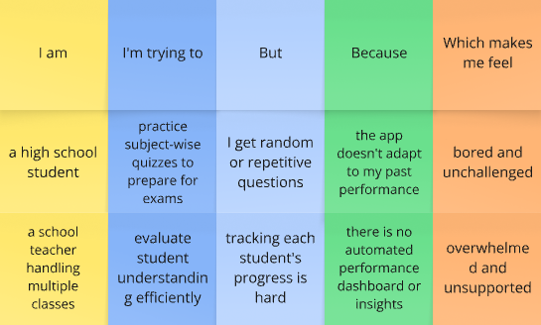

|  |  |  |  |  |  |
| --- | --- | --- | --- | --- | --- |
| **Problem Statement (PS)** | **I am (Customer)** | **I’m trying to** | **But** | **Because** | **Which makes me feel** |
| PS-1 | a school student | improve my subject understanding | I get irrelevant or generic questions | the platform doesn't generate personalized or grade-appropriate quizzes | confused and unmotivated |
| PS-2 | a school teacher | assess my students' learning levels | it's hard to track progress easily | there's no smart dashboard or integration with Google Classroom | overwhelmed and unsupported |